# Name:____________________

Power Supply

Test

1. Given the following voltage regulated power supply circuit, find:

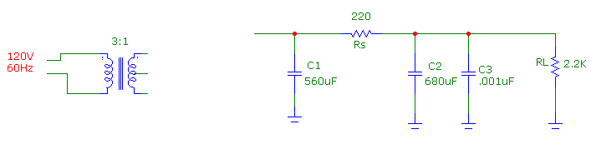

B

A

VDC(A) __________________ VDC(B)_____________________

Vrpp(A)___________________ Vrpp(B)______________________

1. Given the following power supply circuit, Solve for Vmax of 20V and Vmin of 7V. Solve R1 and R2 at mid voltage with a load current of 500mA. Design so that Ic current of Q3 is 5mA and Current through the diodes below R1 is 10mA.

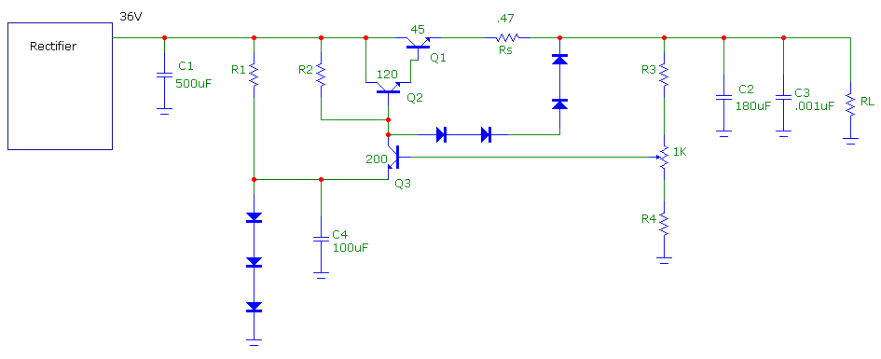

R1=______________ R2=________________ R3=______________ R4=_______________

Short Circuit Current=___________________ PQ1 with output shorted=_________________

1. Find the calculated values of R1 and R2 for an adjustable current limit of 250mA to 1A.

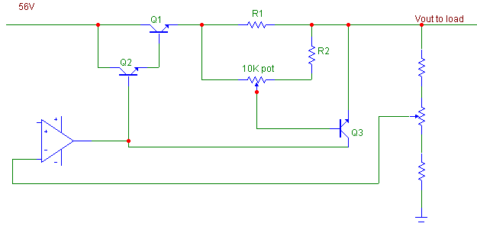

R1 = _________________ R2 = __________________

1. Find the limits of the overvoltage protection circuit in the schematic below. The SCR’s gate voltage is 1.4V.

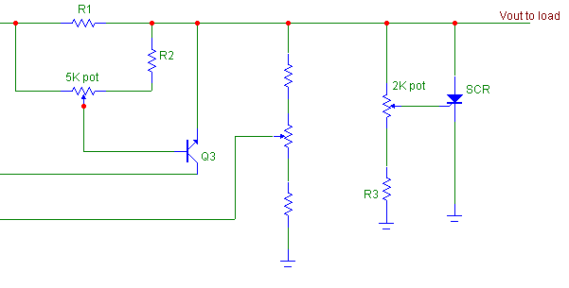

150.5

OverVoltage Max = __________________

OverVoltage Min = __________________

1. List 3 types of Switch Mode Power Supplies. Describe what each type does(Step-Down, Step-Up or Invert).
2. __________________________ ______________________________
3. __________________________ ______________________________
4. __________________________ ______________________________
5. What is one major advantage to a SMPS over a Linear voltage regulator?

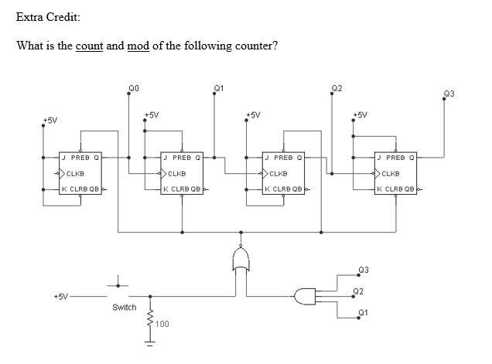

+2.5%

+1.25%

Extra Credit:

From the Original Star Wars Trilogy, how many forms of communications is C-3PO fluent in?

+1.25%

Extra Credit:

What is Luke Skywalker’s Aunt and Uncle’s profession on Tattoine?